**BitByte**

**Project Name:** Personalised nutrition and fitness tracking system.

**Group Members:** Syed Sufyaan(SE22UECM046)

Ishayu Sharma(SE22UECM015)

Vasu Deshmukh(SE22UECM084)

Ayaz Ahmed(SE22UARI024)

Hamza Babukhan(SE22UARI208)

**Overview:** The Personalized Nutrition and Fitness Tracking System is designed to help users track their daily food intake, exercise routines, and overall fitness progress. The system combines the functionality of nutritional tracking with fitness performance visualization. Users can log their meals and monitor their workouts by visualizing workout data over time. This system is highly personalized to cater to individual fitness goals and nutritional needs.

Now, moving on to the functionality of the project.

When we first run the project, we get the login/register page:

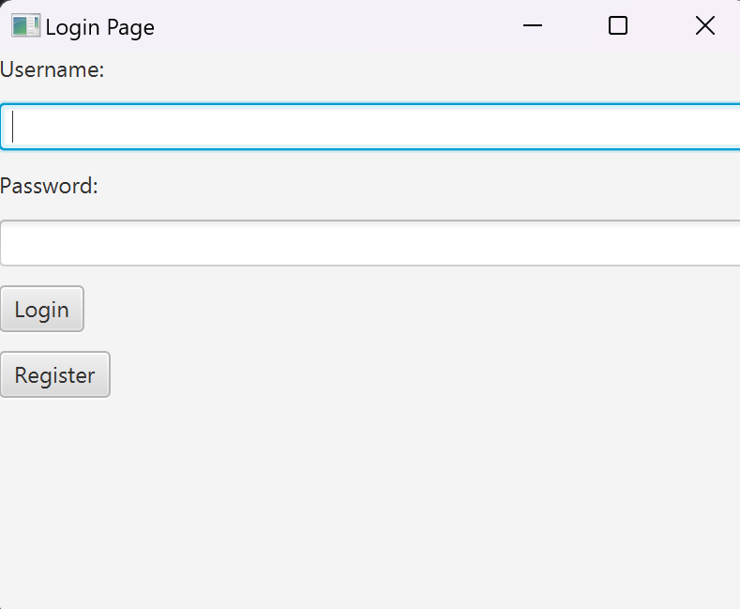 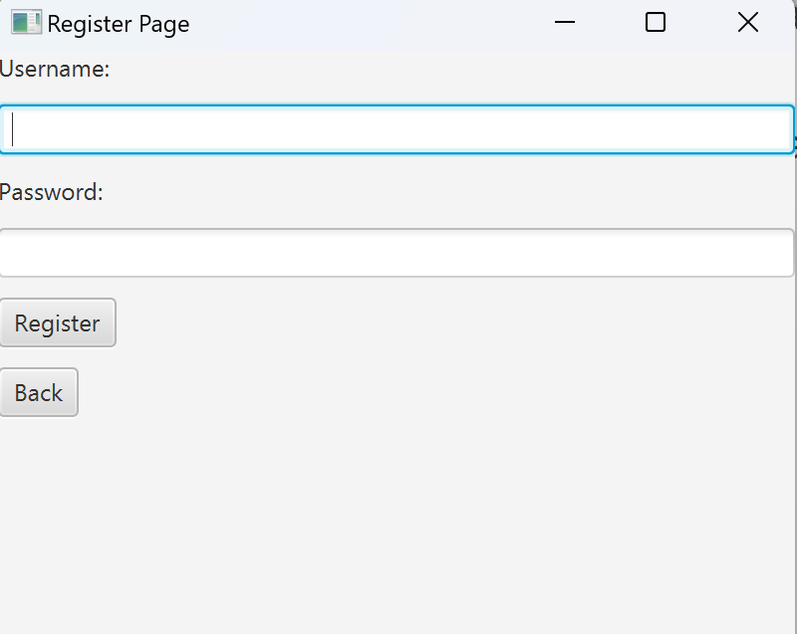

Working of login/register with mysql example:

Let’s say you are registering with a new account named ‘oops’.

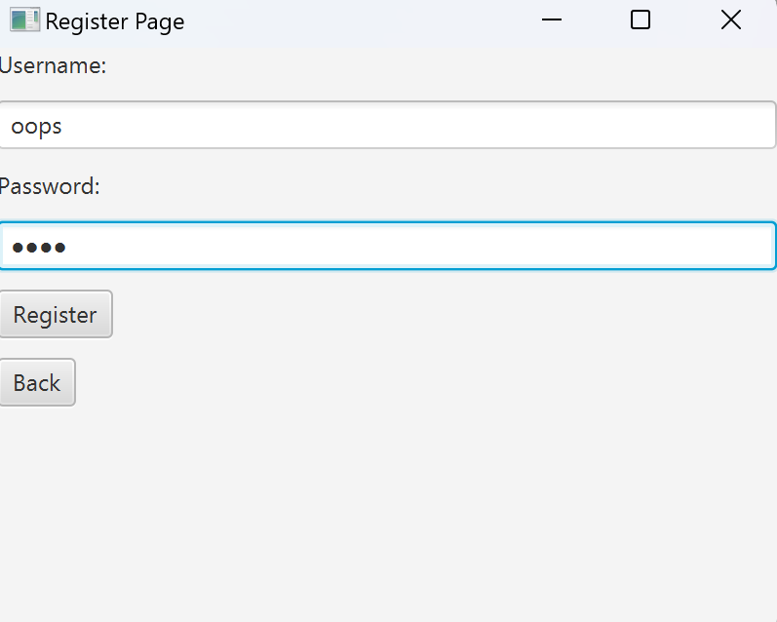

This account is saved in the database in the ‘Users’ table.

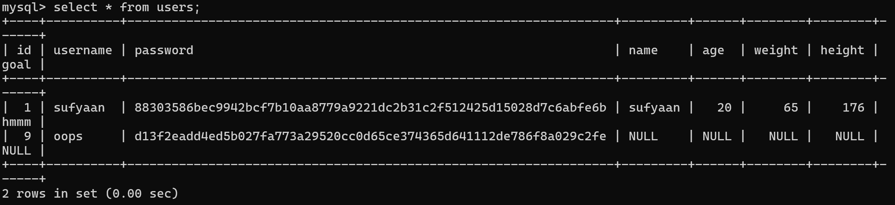

Now when you login, you see this page. 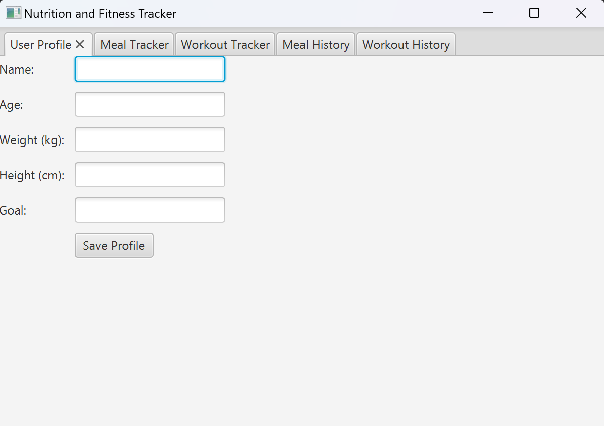

The ‘User Profile’ Page is where you can enter your details.

When you click on ‘Save Profiles’, your details are also saved in the ‘Users’ table in mysql.

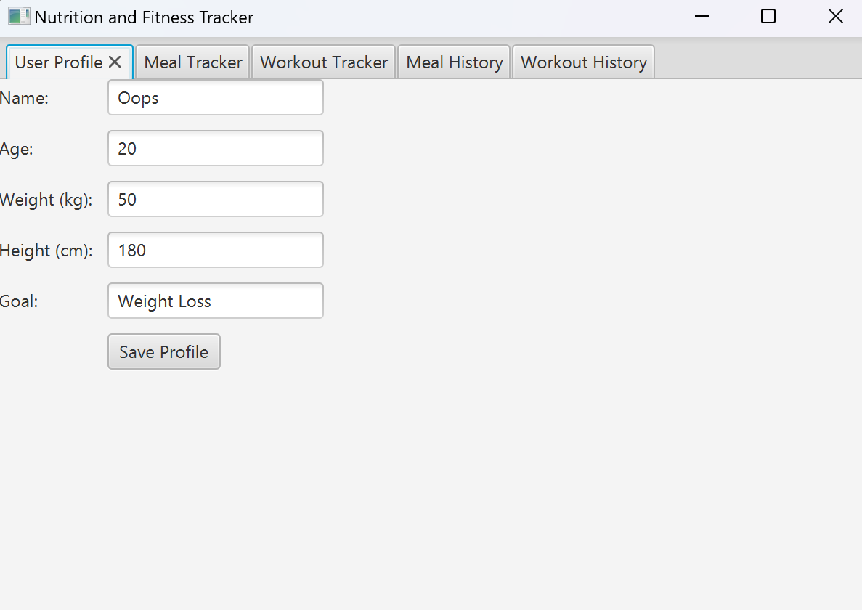

Once you save your profile, your User Profile page will look like this.

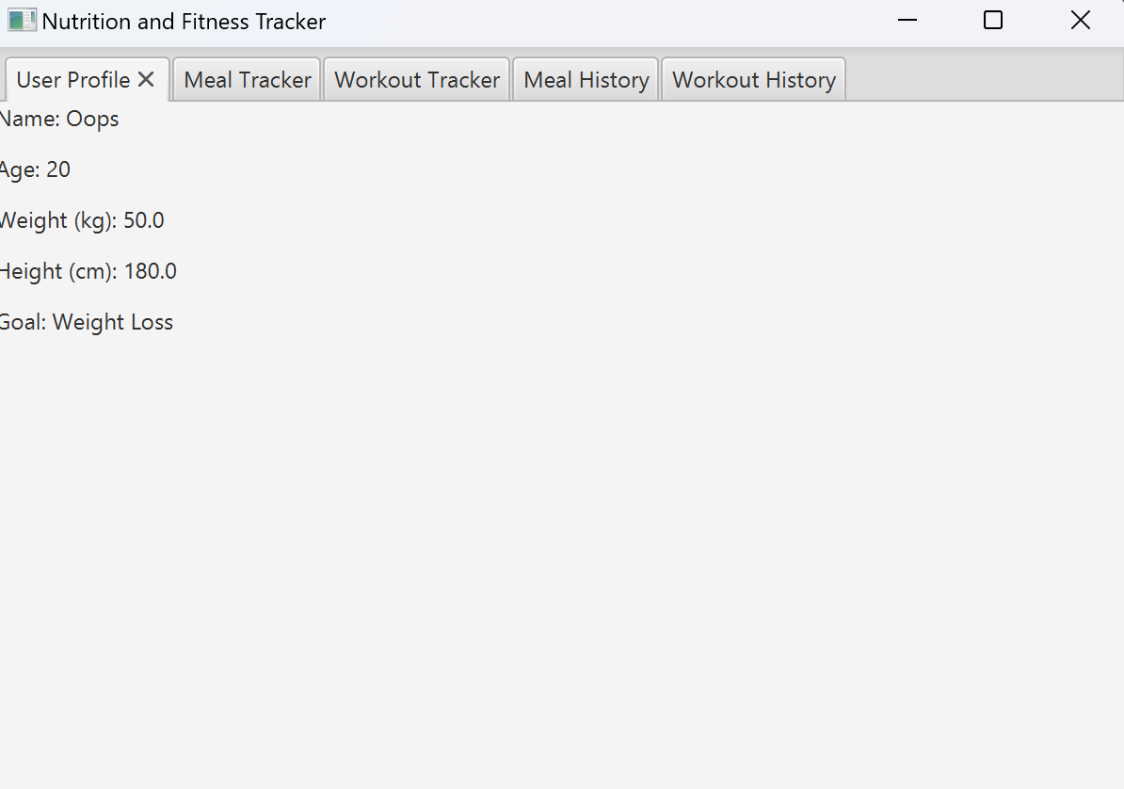

Now, moving on to ‘Workout Tracker’ and ‘Meal Tracker’.

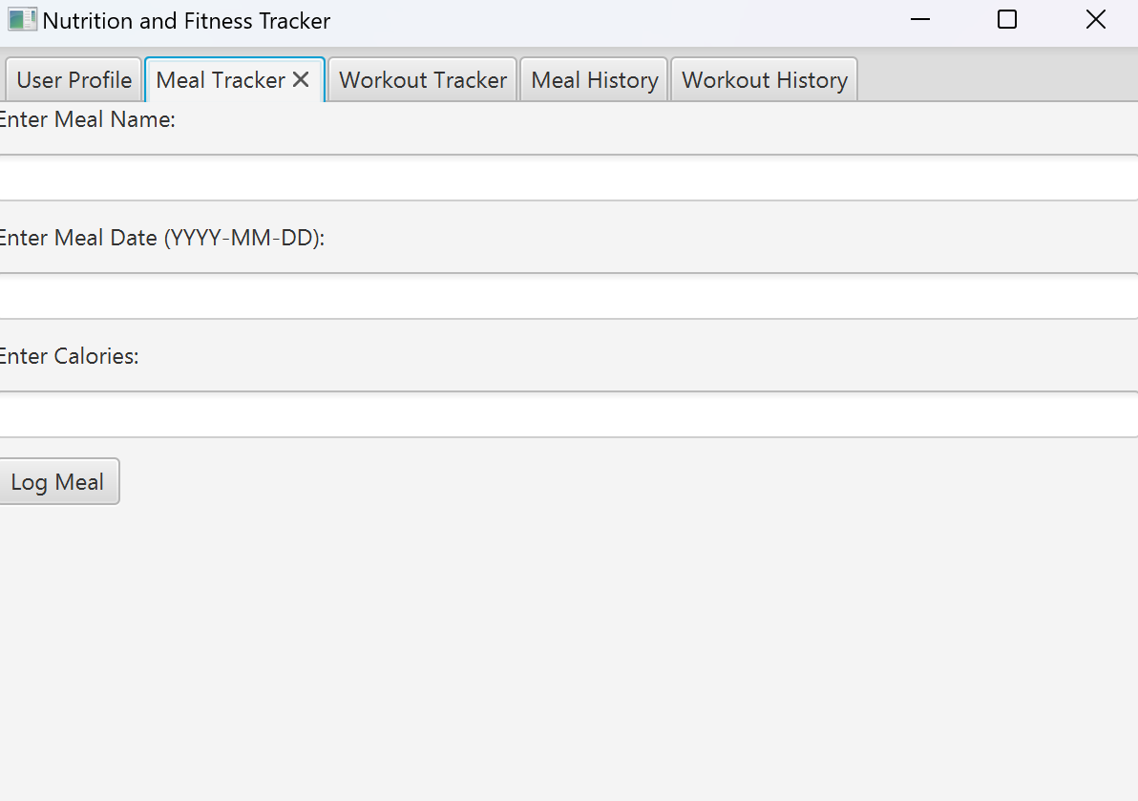 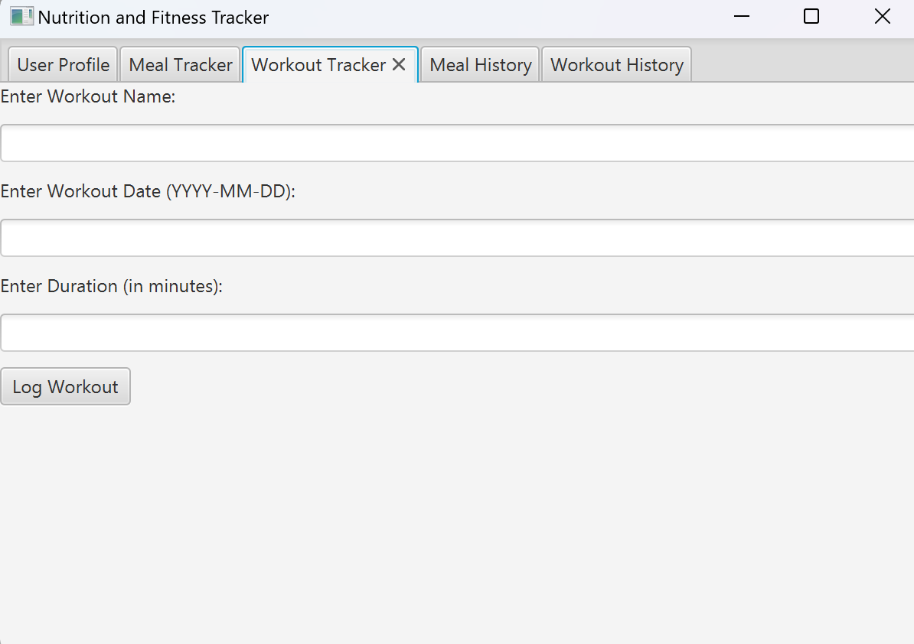

Workout Tracker Page

Meal Tracker Page

On these pages, you have the option to log your meals or workouts which are then saved in the database in the ‘meals’ and ‘workout’ tables respectively.

Example:

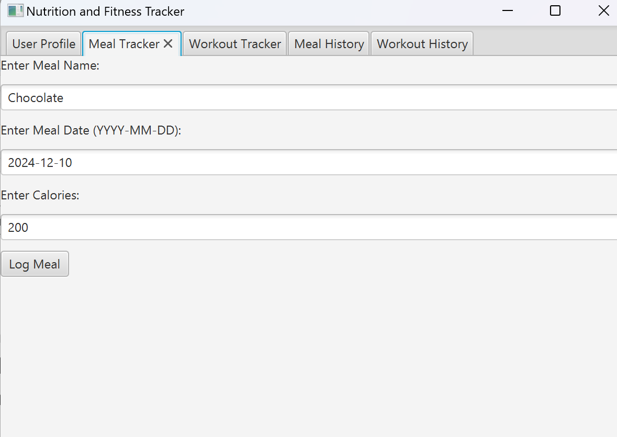

Now in the database,

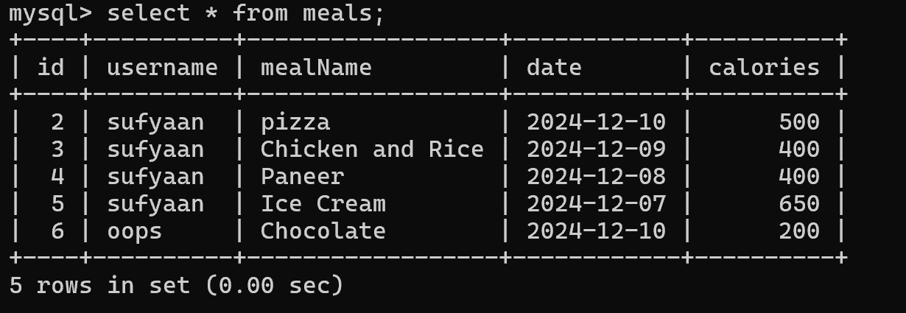

Similarly, you can log workouts.

We have also added an option to view your meal and workout history.

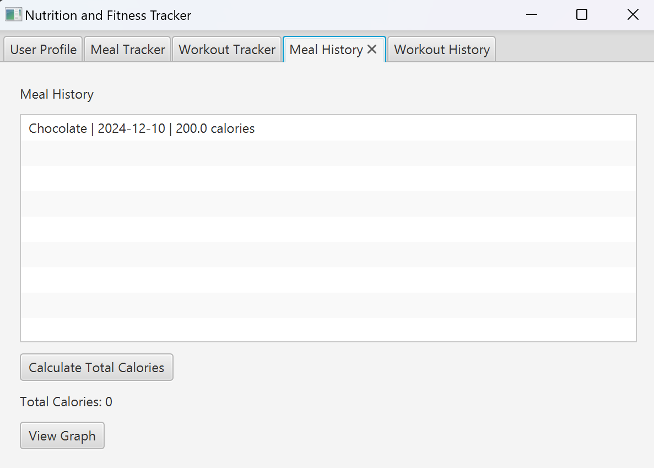 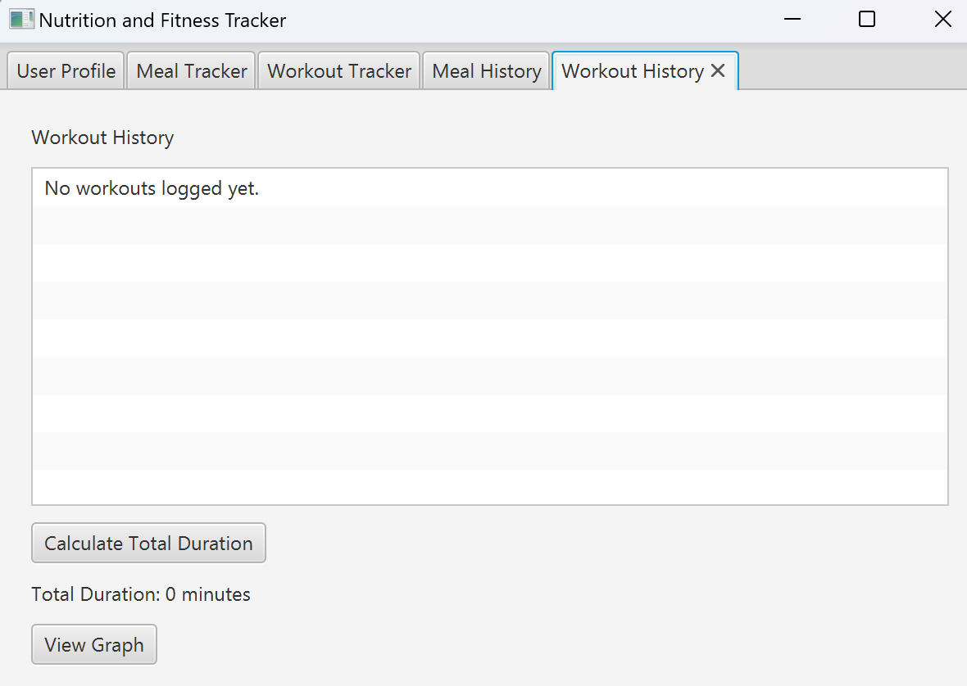

Now we will use the account that we made to demonstrate the rest of the features.

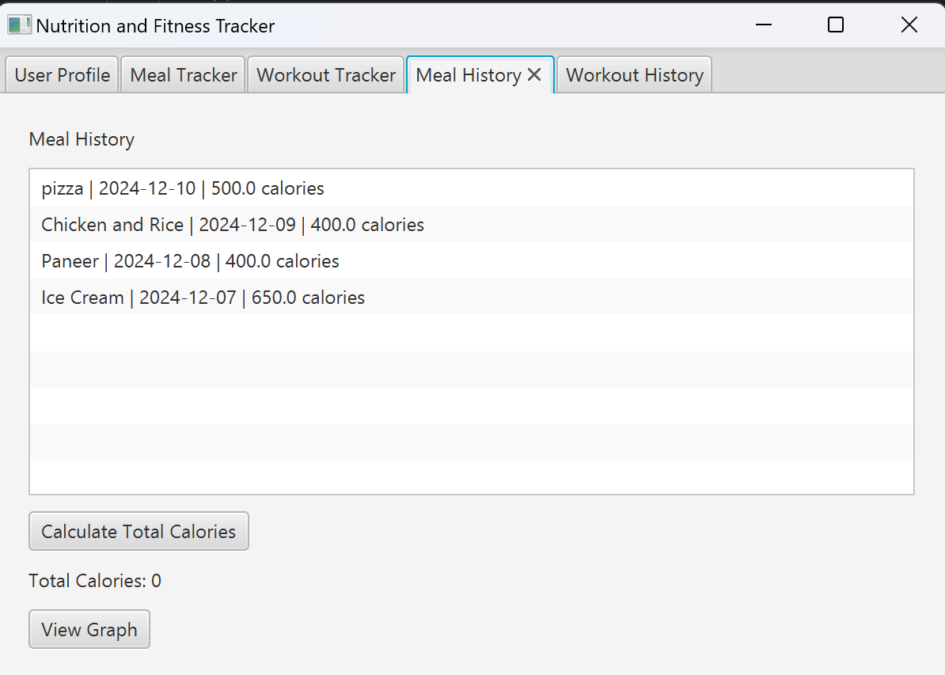 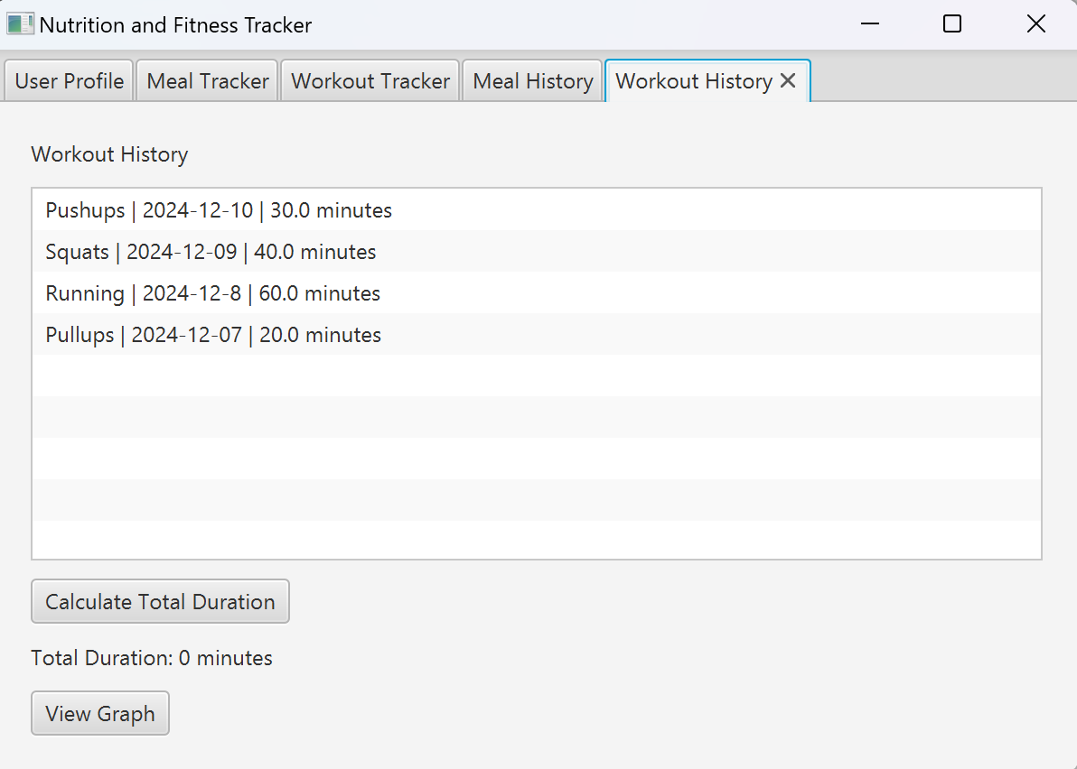

These are some of the meals and workouts we logged before.

When we click on the ‘Calculate Total Calories’ and ‘Calculate Total Duration’ buttons it displays the total calories you have consumed and the total minutes that you have worked out. 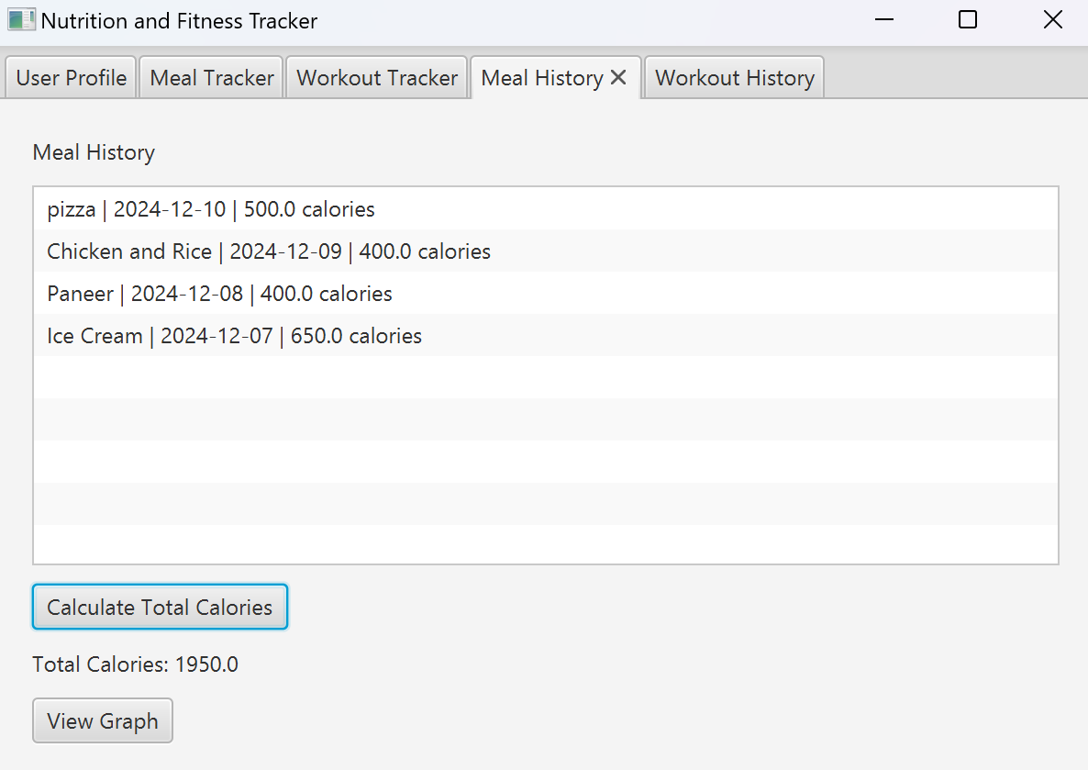 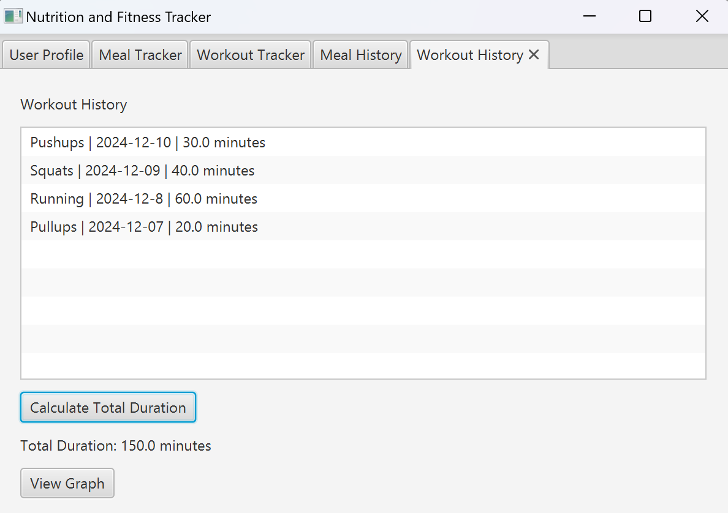

The last feature we have added is the ‘View Graph’ button to both ‘Meal History’ and ‘Workout History’.

We used JavaFX charts to represent your meal and workout data graphically.

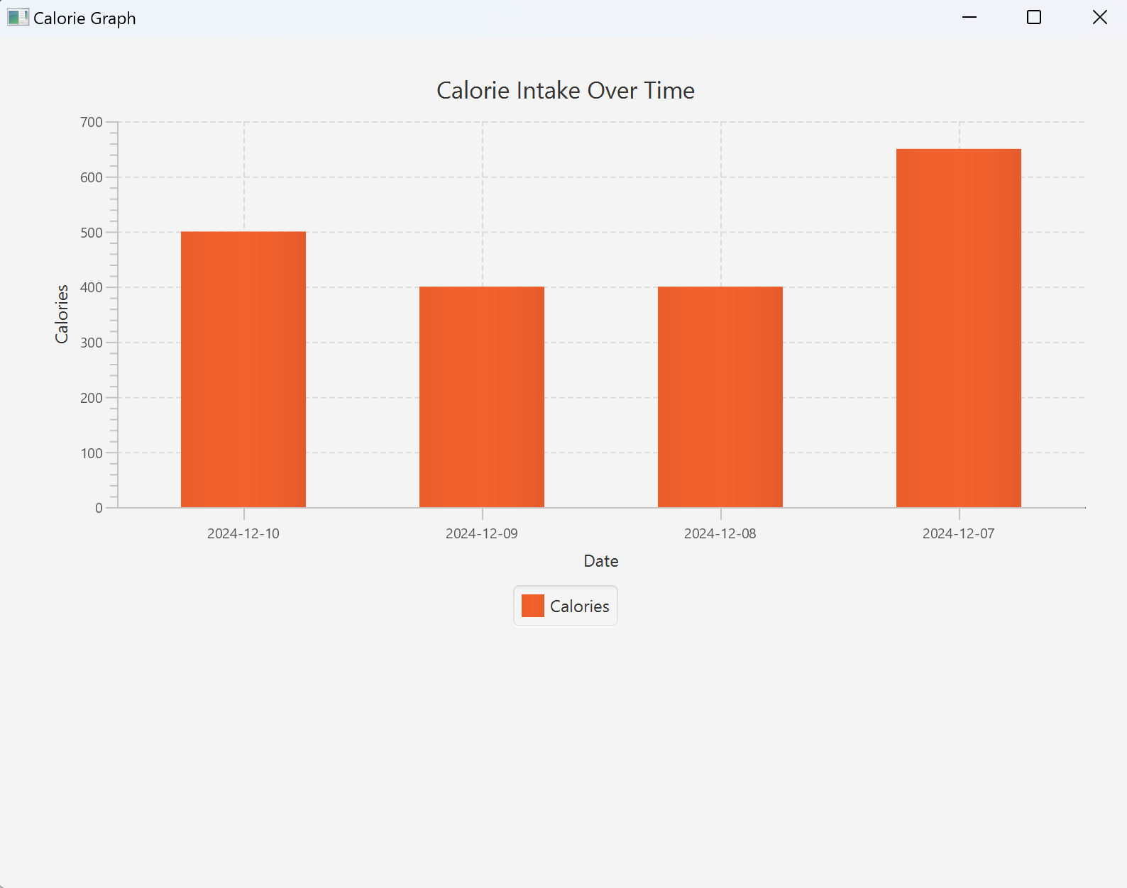

Meal History Graph

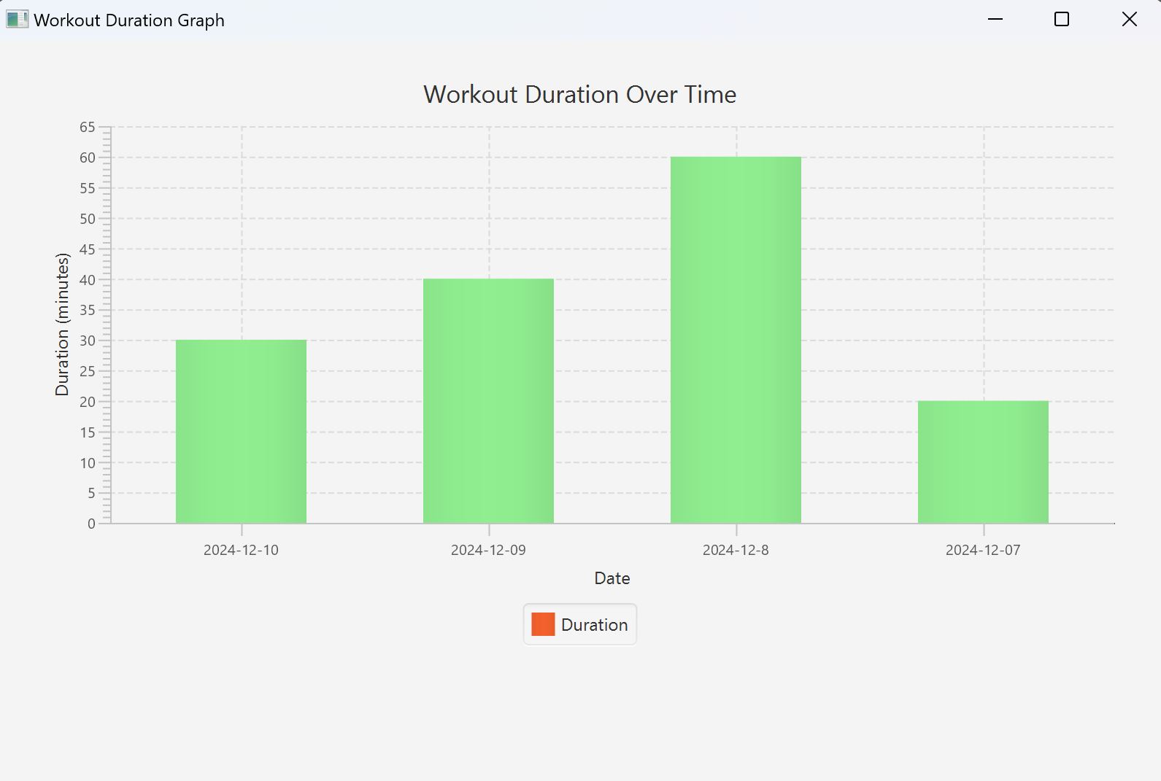

Workout History Graph

**OOPS Principles that we used:**

**1)Encapsulation:**

Data classes like User, Meal, and Workout encapsulate related attributes and methods.

**2)Inheritance:**

The MealTracker and WorkoutTracker classes inherit from the Tracker base class.

Shared functionality like logDetails() is defined in the Tracker class and reused in the child classes.

**3)Polymorphism:**

Method overriding: The logDetails() method is customized in both MealTracker and WorkoutTracker classes to handle meal-specific or workout-specific data while retaining a common interface.

**What we can do to improve the project:**

1. Add Edit profile option in user profile page.
2. Add a delete workout/meal option in workout/meal history pages.
3. Integrate it with a smartwatch api to log workout details automatically.
4. Make a more appealing frontend.